Project Synopsis

Project Title: AI-Based Resume Analysis System using FastAPI and Streamlit

1 Introduction
In today’s competitive job market, recruiters receive hundreds of resumes for a single job opening. Manually screening resumes is time-consuming and inefficient. To automate this process, an intelligent system is required that can analyze resumes and compare them with job descriptions.
The AI-Based Resume Analysis System is a full-stack web application developed using FastAPI (backend) and Streamlit (frontend) that evaluates resumes against job descriptions using Natural Language Processing (NLP) techniques. The system calculates a match score and identifies missing keywords, helping candidates improve their resumes.

2 Problem Statement
- Manual resume screening is time-consuming.
- Candidates lack clarity on how well their resume matches job descriptions.
- Recruiters need an automated filtering system.
The project aims to build an intelligent resume evaluation tool.

3 Objectives
- Extract text from PDF resumes.
- Compare resume with job description.
- Calculate similarity score using NLP.
- Identify missing keywords.
- Provide improvement suggestions.
- Implement full-stack integration using REST APIs.

4 Technology Stack
Component | Technology
Frontend | Streamlit
Backend | FastAPI
Language | Python
NLP | TF-IDF
Similarity Metric | Cosine Similarity
PDF Extraction | PyMuPDF
API Communication | REST API

5 System Architecture
User Upload Resume
↓
Streamlit Frontend
↓
FastAPI Backend (REST API)
↓
Text Extraction (PyMuPDF)
↓
TF-IDF Vectorization
↓
Cosine Similarity
↓
Match Score + Missing Keywords
↓
Display Results

6 Methodology
- Resume is uploaded in PDF format.
- FastAPI backend extracts text from the PDF.
- User enters job description.
- Both texts are converted into TF-IDF vectors.
- Cosine similarity is calculated.
- Match percentage is generated.
- Missing keywords are identified.
- Results are displayed on Streamlit interface.

7 Implementation Steps (CMD Execution)

Step 1: Open Project Directory
cd path\to\resume_analyzer
Example:
cd D:\Projects\resume_analyzer

Step 2: Create Virtual Environment
python -m venv venv
Activate virtual environment:
venv\Scripts\activate

Step 3: Install Backend Dependencies
cd backend
pip install -r requirements.txt

Step 4: Run FastAPI Backend
uvicorn main:app --reload
If uvicorn is not recognized:
python -m uvicorn main:app --reload
Backend runs at:
http://127.0.0.1:8000
API Documentation:
http://127.0.0.1:8000/docs

Step 5: Open New CMD for Frontend
cd path\to\resume_analyzer
venv\Scripts\activate
cd frontend
pip install -r requirements.txt

Step 6: Run Streamlit Application
streamlit run app.py
If streamlit is not recognized:
python -m streamlit run app.py
Frontend runs at:
http://localhost:8501

8 Key Features
- Resume PDF Upload
- NLP-based Skill Matching
- Resume-JD Similarity Score
- Missing Keyword Identification
- REST API Integration
- Interactive UI

9 Results
The system successfully:
- Extracts resume text
- Computes similarity score
- Identifies skill gaps
- Displays percentage match
- Provides keyword suggestions
The model accurately calculates similarity using TF-IDF and cosine similarity techniques.

10 Advantages
- Saves recruiter time
- Helps candidates optimize resumes
- Easy to use interface
- Scalable backend architecture
- Modular and deployable

11 Future Enhancements
- Upgrade to BERT/Sentence Transformers
- Add resume ranking system
- Store resumes in database
- Add authentication system
- Docker deployment
- Cloud hosting (AWS/Render)

App Code
import streamlit as st
import requests

st.set_page_config(page_title="Resume Analyzer", layout="centered")

st.title("📄 AI Resume Analyzer")

uploaded_file = st.file_uploader("Upload Resume (PDF)", type=["pdf"])

if uploaded_file:
files = {"file": uploaded_file.getvalue()}
response = requests.post("http://127.0.0.1:8000/upload", files={"file": uploaded_file})
resume_text = response.json()["resume_text"]

jd = st.text_area("Paste Job Description")

if st.button("Analyze"):
data = {
"resume_text": resume_text,
"job_description": jd
}
result = requests.post("http://127.0.0.1:8000/analyze", json=data)
result_json = result.json()

st.subheader("📊 Match Score")
st.success(f"{result_json['match_score']} %")

st.subheader("❌ Missing Keywords")
st.write(result_json["missing_keywords"])

Output

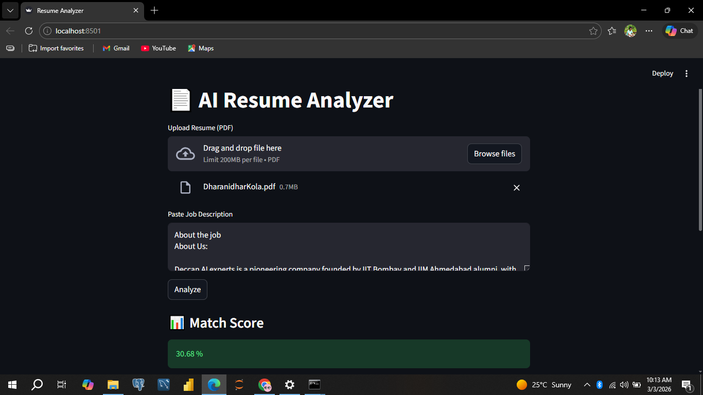

12 Conclusion
The AI-Based Resume Analysis System demonstrates how NLP and web technologies can automate resume screening. By integrating FastAPI and Streamlit, the project provides an efficient, scalable, and intelligent solution for resume evaluation. The system bridges the gap between job seekers and recruiters through automated resume matching.

